

Year 12 ATAR Chemistry

Topic Test

Organic Molecules Test

2017

Name: ___________________________

Teacher:___________________________

|  |  |  |  |
| --- | --- | --- | --- |
| Section | Possible mark | Actual Mark | Percentage |
| A: Multiple Choice | 10 |  |  |
| B: Short Answer | 40 |  |  |
| TOTAL | 50 |  |  |

Time permitted for completion of the test: 55 minutes.

**Multiple choice 10 marks**

1. In which of the following alternatives are the three compounds listed in order of increasing boiling point?
2. Pentane, butan-1-ol, propanoic acid
3. Propanoic acid, butan-1-ol, pentane
4. Propanoic acid, pentane, butan-1-ol
5. Butan-1-ol, propanoic acid, pentane
6. The raspberry-flavoured food additive, butyl methanoate, can be prepared from CH3CH2CH2CH2OH using
7. an addition reaction with HCOOH.
8. an addition reaction with CH3COOH.
9. a condensation reaction with HCOOH.
10. a condensation reaction with CH3COOH.
11. Which compound is least soluble in water?
12. CH3CH2CH2F
13. CH3CH2CH2NH2
14. CH3CH2CH2OH
15. CH3CH2CH2COOH
16. How many different aldehydes have the formula C5H10O?
17. 2
18. 3
19. 4
20. 5
21. The boiling points of CH3COCH3, CH3COC2H5, and CH3COC3H7 are 56 °C, 80 °C, and 102 °C, respectively. This increase is best attributed to an increase in which of the following?
22. Dipole-dipole interactions
23. Dispersion forces
24. Hydrogen bonding
25. i. only
26. ii. only
27. iii. only
28. ii. and iii. only
29. Pure samples of which of the following exhibit hydrogen bonding?

I CH3OH

II CH3NO2

III CH3CN

1. I only
2. I and II only
3. II and III only
4. I, II and III
5. The compound that is not an isomer of 2,2,4-trimethylpentane is:
6. octane
7. 3-ehylhexane
8. 2,4-dimethylpentane
9. 2, 4 dimethylhexane
10. Which one of the following represents an alpha amino acid?







1. 

1. Which one of the following pairs represent monomers that could react together to form a polymer?





1. i and iv
2. I and iii
3. Ii and iii
4. Iii and iv
5. Proteins that show a high degree of similarity in their primary structure in the Protein Data Bank are most likely to have:
6. Similar function
7. Identical tertiary structure
8. Been isolated from the same species
9. The same amino acid composition

**Short Answer 40 marks**

1. Fill in the following table.

|  |  |
| --- | --- |
| **Name** | **Structural formula** |
|  |  |
| Trans-3-heptene |  |
|  |  |
| 1, 1-dichloro-cis-2-butene |  |
|  | Image result for propanoic  acid structure |
|  | Image result for 3-hexanone structure |

[6]

1. DRAW and NAME the major organic PRODUCT or PRODUCTS in the following reactions assuming appropriate conditions. NB. No balancing is required.

(a) Propanoic acid and potassium hydroxide solution.

_________________________

(b) Cyclohexene and bromine.

________________________

[2 marks]

1. An unknown organic compound contains only carbon, hydrogen and oxygen. A 0.275g sample of the compound was combusted in excess oxygen to yield 0.403g of carbon dioxide and 0.165g of water.
2. Determine the empirical formula of the compound.

[6]

1. Given that a 1.50g sample of the same compound, when vapourised, occupied 498.5mL at 295K and 123.0 kPa, determine the molecular formula of the compound.

[3]

1. Had the organic compound turned blue litmus pink, draw its molecular structure and name it.

[2]

1. Using the graph below answer the following questions:

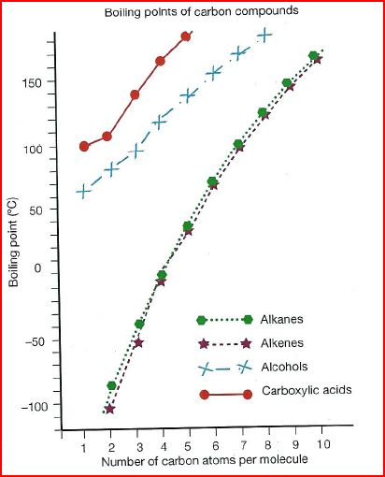

1. Explain in general terms why the boiling point for all the functional groups increases with increasing number of carbon atoms per molecule.

_________________________________________________________________________________________________________________________________________________________________________________________________________________________________

[2]

1. From the graph it is clear that alkanes and alkenes generally have much lower boiling points than alcohols and carboxylic acids. Account for this in terms of forces these different functional groups have.

____________________________________________________________________________________________________________________________________________________________________________________________________________________________________________________________________________________________________________

[4]

1. In terms of solubility explain which groups are more likely to be soluble in a polar solvent. ____________________________________________________________________________________________________________________________________________________________________________________________________________________________________________________________________________________________________________

[2]

1. Draw the four structural isomers of C4H9Cl and name them.

[4]

1. Examine the structure below that represents a segment of the primary structure of insulin to answer the questions that follow.



1. Circle all the peptide linkages (functional groups that link the monomers) represented in the above structure.

[1]

1. Draw the molecular structures of the three α-amino acids that form this segment of insulin.

[3]

1. The diagram below represents a segment of protein, showing the types of interactions that can occur between amino acid side chains to form the tertiary structure.
2. Identify these types of interactions, labelled A, B, C and D, by completing the table below:

|  |  |
| --- | --- |
| **Label** | **Interaction** |
| **A** |  |
| **B** |  |
| **C** |  |
| **D** |  |

[4]

1. State what is meant by the tertiary structure of a protein.

__________________________________________________________________________________________________________________________________________________________________________________________________________________________________________

[1]